

NAAN MUDHALVAN-SALESFORCE REPORT

**WORKFORCE ADMINISTRATION SOLUTION (DEV)**

PROJECT CREATED BY

Shree Chaithanya.L (422422104027)

Parasuraman.P (422422104028)

Dhanushkodi.R (422422104029)

Hema.R (422422104030)

DEPARTMENT OF COMPUTER SCIENCE AND ENGINEERING

UNIVERSITY COLLEGE OF ENGINEERING TINDIVANAM



COLLEGE CODE – 4224

ANNA UNIVERSITY,CHENNAI-60025



**TABLE OF CONTENT:**

1. Project overview 3

1. Objectives 3

1. Key features and concept 5

1. Detailed steps to solution design 5

1. Testing and validation 5

1. Key scenerios addressed by salesforce in this

Implementation process 6

1. Step by Step Process Explanation 6

1. Conclusion 25



WORKFORCE ADMINISTRATION SOLUTION (DEV)

**1.PROJECT OVERVIEW:**

* The project involves implementing a Workforce Administration Solution using Salesforce to streamline employee management, time tracking, scheduling, and payroll integration. The solution aims to improve workforce efficiency, ensure compliance with labor laws, and optimize the overall administrative process.

**2.PROJECT OBJECTIVIES:**

* Enhance employee data management.
* Streamline time and attendance tracking.
* Automate scheduling and shift management.
* Integrate payroll processes.
* Ensure compliance with labor regulations.
* Improve reporting and analytics capabilities.
* Increase user satisfaction through better interface and UX.
* Implement a quick, easy approval process to reduce delays and manual work.
* Enforce rules to ensure lease data is entered correctly and consistently.



**FIGURE 1:**

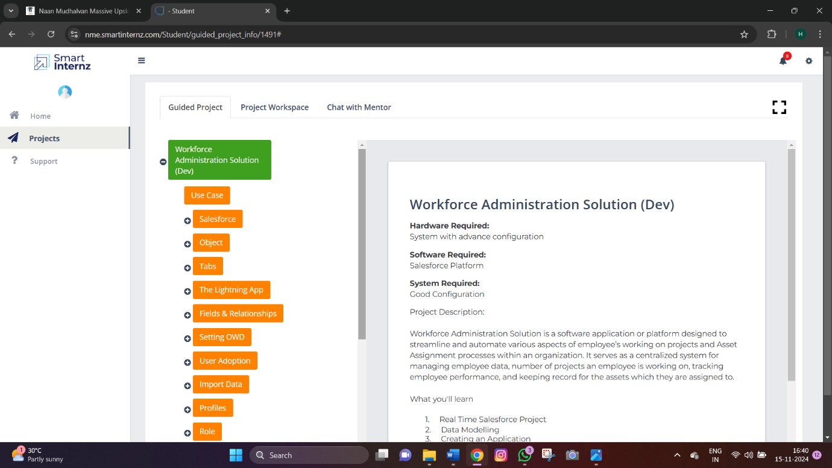

**3.KEY FEATURES AND CONCEPTS:**

* Salesforce Lightning Platform: Provides a modern, responsive user interface for managing workforce-related data.
* Salesforce Flow: Automates business processes such as employee onboarding and time-off requests.
* Salesforce Reports & Dashboards: Enables detailed analytics and performance monitoring.
* Apex: Custom code for complex business logic, such as payroll calculations or time tracking rules.
* Salesforce Object Manager: Used to configure and manage custom objects like employee records, shifts, and attendance logs.
* Salesforce Data Integration: Integrates with external systems for payroll and HRMS.

### 

**4.DETAILS STEPS TO SOLUTION DESIGN:**

* Requirement Gathering: Meet with stakeholders to identify functional and technical requirements.
* Data Model Design: Design custom objects (Employee, Shift, Attendance, etc.) and relationships between them.
* Process Automation: Implement Salesforce Flow for automating attendance, scheduling, and approvals.
* User Interface Design: Customize Lightning pages to create an intuitive UI for HR admins and employees.
* Integration: Connect Salesforce with external payroll and HR systems via APIs or middleware.
* Security Configuration: Set up profiles, permissions, and data access levels for different user roles.
* Testing: Prepare test cases for system validation and perform unit, integration, and user acceptance testing.
* Deployment: Deploy the solution to production using change sets or Salesforce DX.

**5.TESTING AND VALIDATION:**

* Unit Testing: Validate individual components, such as custom Apex code or Flows.
* Integration Testing: Test the integration with external payroll systems to ensure data sync.
* User Acceptance Testing (UAT): HR and employee representatives test the solution to ensure it meets business needs.
* Performance Testing: Ensure the system can handle large data volumes, especially during payroll periods.
* Security Testing: Verify data security controls, such as access restrictions and encryption.



**6.KEY SCENARIOS ADDRESSED BY SALESFORCE IN THIS IMPLEMENTATION PROCESS:**

Employee Onboarding: Automating the onboarding process through Salesforce Flow.

* Payroll Integration: Ensuring seamless transfer of attendance data to payroll systems for accurate compensation.
* Compliance Monitoring: Alerts and reporting to ensure compliance with labor laws and company policies.
* Reporting & Analytics: Providing management with real-time workforce insights and trends.

**7.STEP BY STEP PROCESS EXPLANATION:**

STEP 1:CREATE A OBJECT:

What Is an Object?

Salesforce objects are database tables that permit you to store data that is specific to an organization. What are the types of Salesforce objects

**FIGURE 2:**

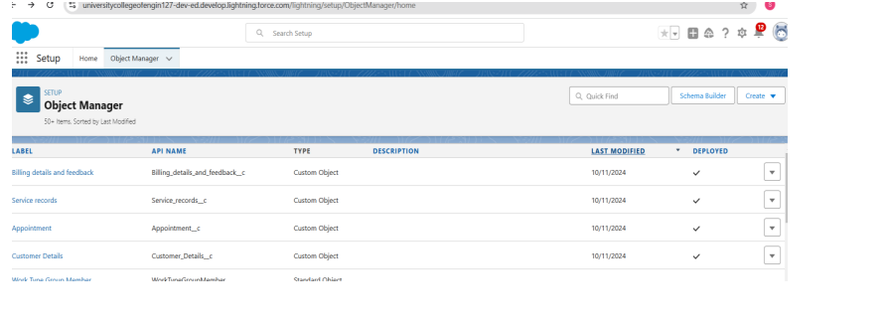STEP 2:CREATE A TABS

**What is Tab:**A tab is like a user interface that is used to build records for objects and to view the records in the objects.

**Types of Tabs:**

1.Custom Tabs

2.Web Tabs



**FIGURE 3:**

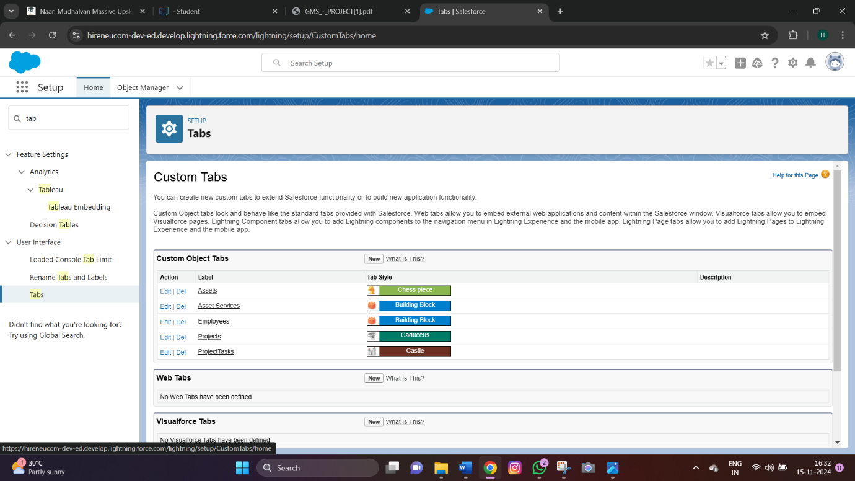

STEP 3:CREATE A LIGHTNING APP

**The Lightning App**

Lightning apps let you brand your apps with a custom color and logo. You can even include a utility bar and Lightning page tabs in your Lightning app. Members of your org can work more efficiently by easily switching between apps.

**Create a Lightning App**

To create a lightning app page:

1.     Go to setup page --> search “app manager” in quick find --> select “app manager” --> click on New lightning App.

2.     Fill the app name in app details and branding as follow  
App Name : Workforce Administrator Solution  
Developer Name : this will auto populated  
Description : Give a meaningful description  
Image : optional (if you want to give any image you can otherwise not mandatory)  
Primary color hex value : keep this default

3.     Then click Next  --> (App option page) keep it as default --> Next --> (Utility Items) keep it as default --> Next.



4.     To Add Navigation Items:

5.  To Add User Profiles:

**FIGURE 4:**

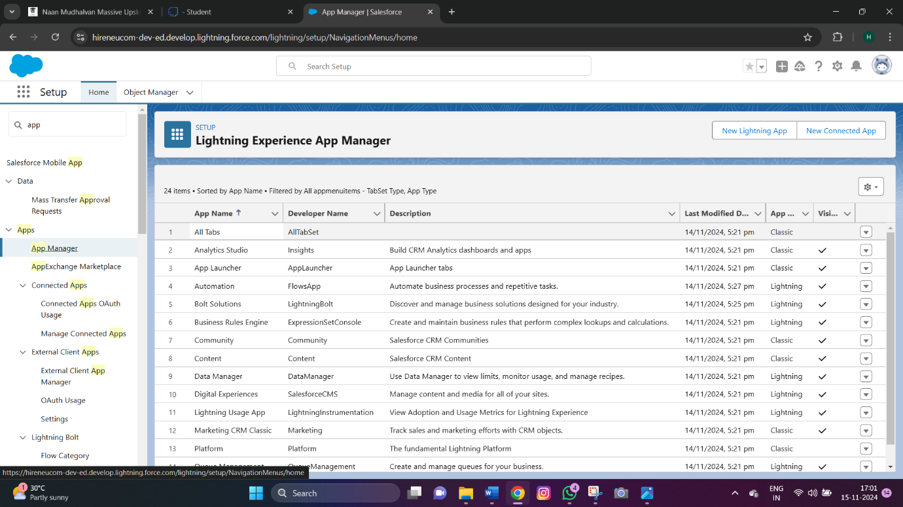

STEP 4:CREATE A FIELDS

**Fields & Relationships**

**What is Fields**

Fields represent the data stored in the columns of a relational database. It can hold any valuable information that you require for a specific object. Hence, the overall searching, deletion, and editing of the records become simpler and quicker.

**Types of Fields**

1.     Standard Fields

2.     Custom Fields



**FIGURE 5:**

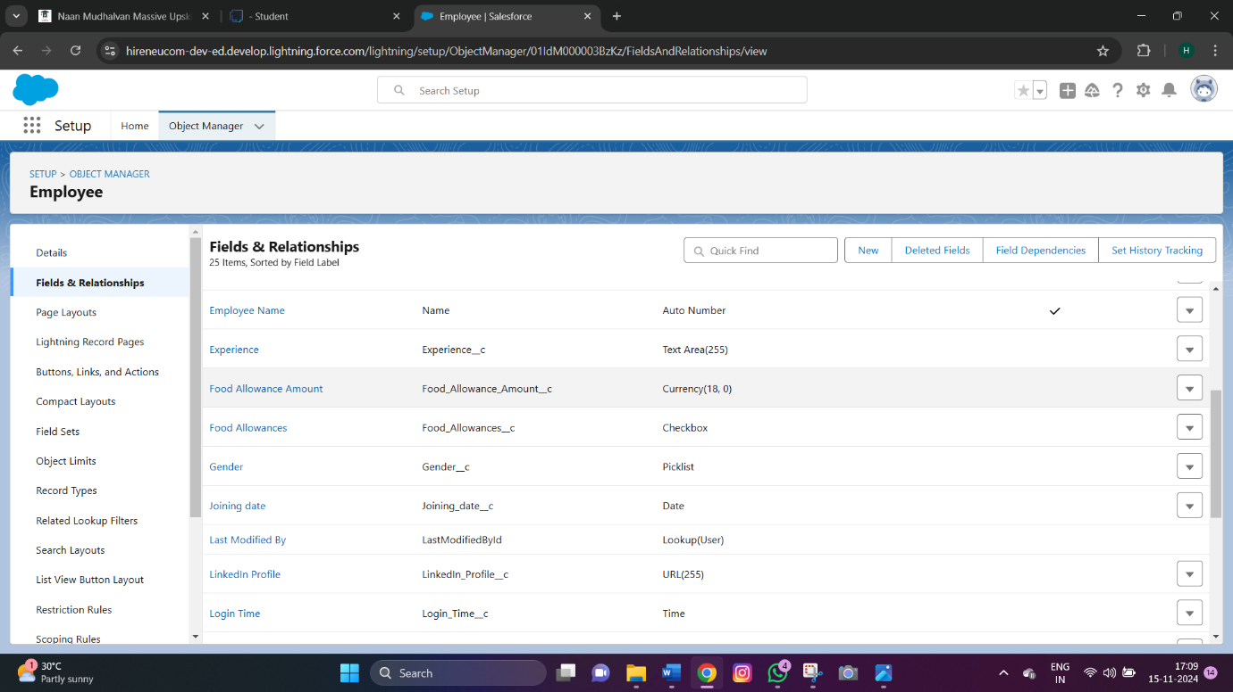

**FIGURE 6:**

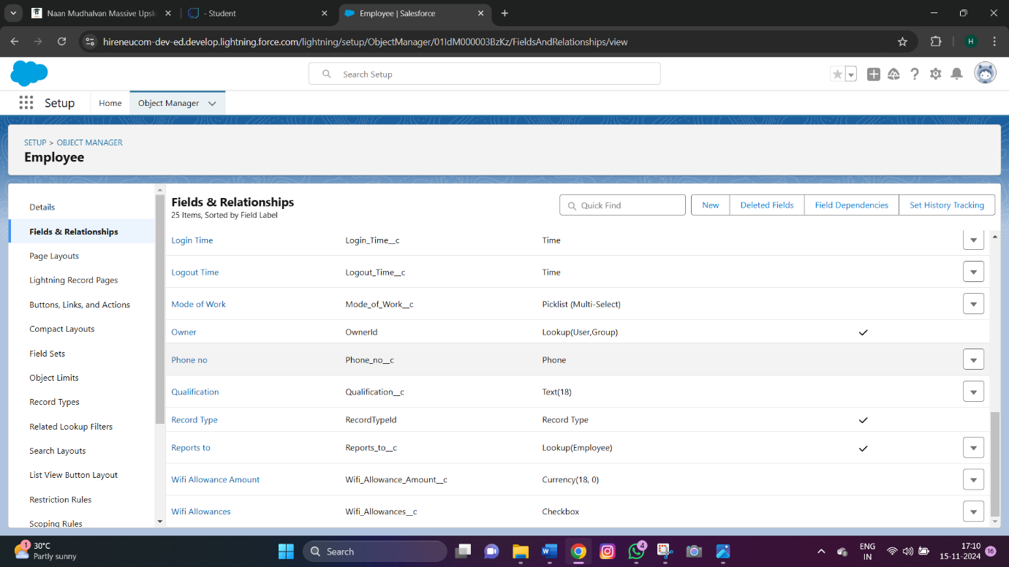



STEP 5 :SETTING OWD

Organization-Wide Defaults, or OWDs, are the pattern security rules that you can follow for your Salesforce instance. Organization Wide Defaults are utilized to confine who can access what information in your CRM. You can award access through different methods that we will discuss later (sharing principles, Role Hierarchy, Sales Teams, and Account groups, manual sharing, and so forth).

**FIGURE 7:**

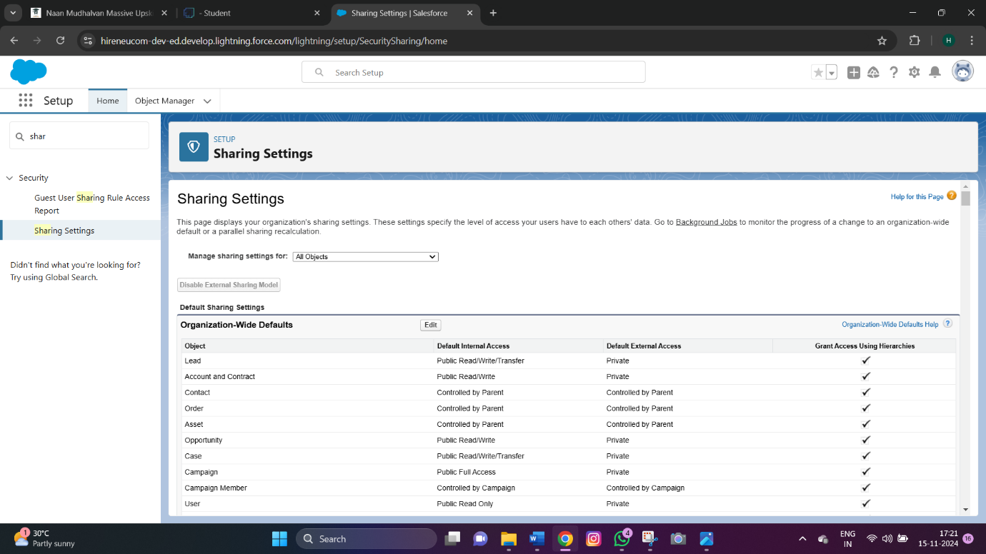

**FIGURE 8:**

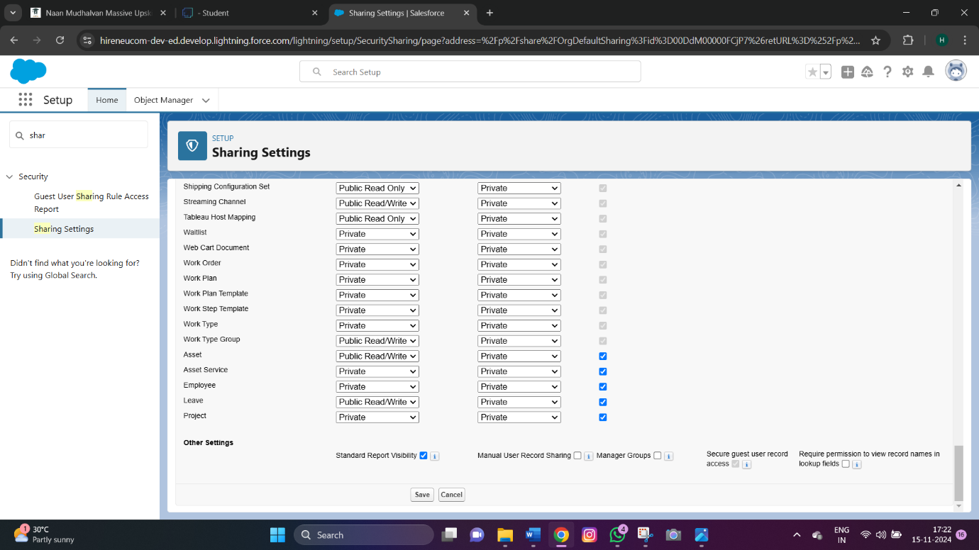



STEP 6: USER ADOPATION

**Activity 1: Create a Record (Employee)**

1. Click on App Launcher on the left side of the screen.
2. Search Employee Management System & click on it.

3.Click on the Employee tab.

4.Click New.

5.Fill the Details and click on Save.

**Activity 2: View a Record (Employee)**

1. Click on App Launcher on the left side of the screen.
2. Search Employee Management System & click on it.
3. Click on the Employee Tab.
4. Click on any record name. you can see the details of the Employee

**FIGURE 9:**

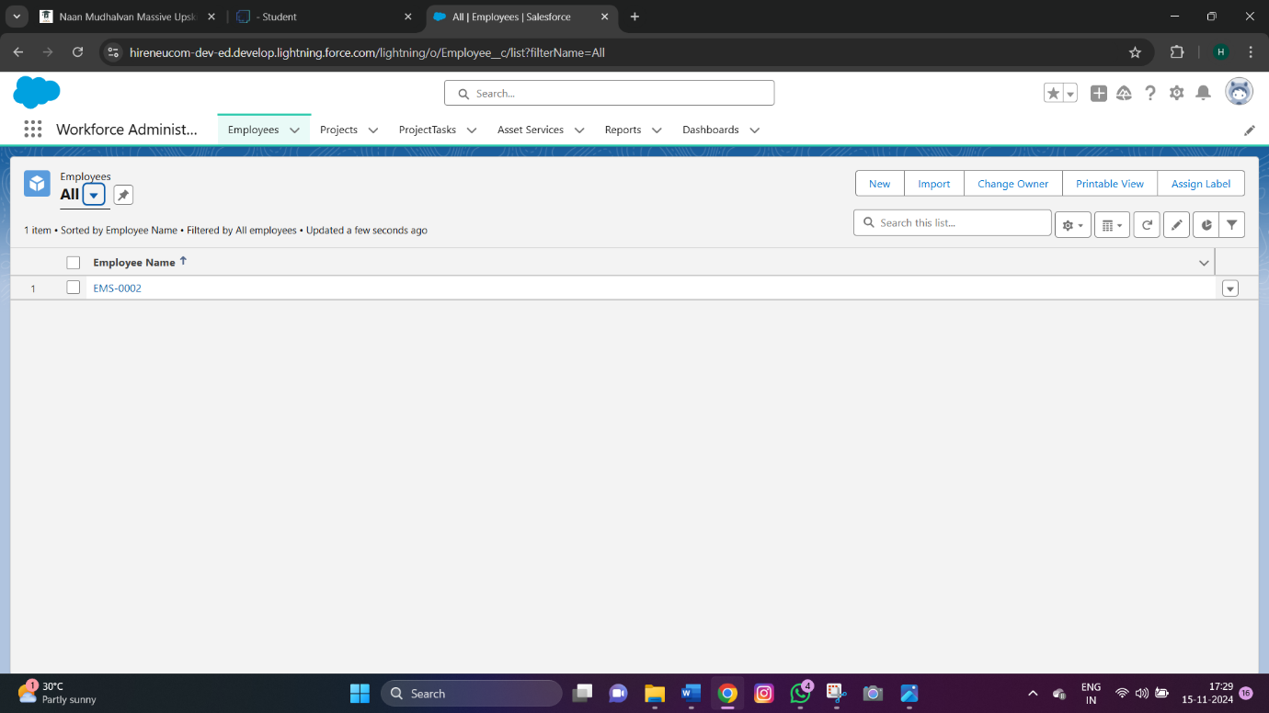



STEP 7:IMPORT DATA

**Import Data**

The Data Import Wizard is a Tool makes it easy to import data for many standard Salesforce objects, including accounts, contacts, leads, solutions, campaign members, and person accounts. You can also import data for custom objects.

STEP 8:PROFILES

**Profiles**

A profile is a group/collection of settings and permissions that define what a user can do in salesforce. Profile controls “Object permissions, Field permissions, User permissions, Tab settings, App settings, Apex class access, Visualforce page access, Page layouts, Record Types, Login hours & Login IP ranges. You can define profiles by the user's job function. For example System Administrator, Developer, Sales Representative.

**Types of profiles in salesforce**

       1. Standard profiles:

2. Custom Profiles:

**FIGURE 10:**

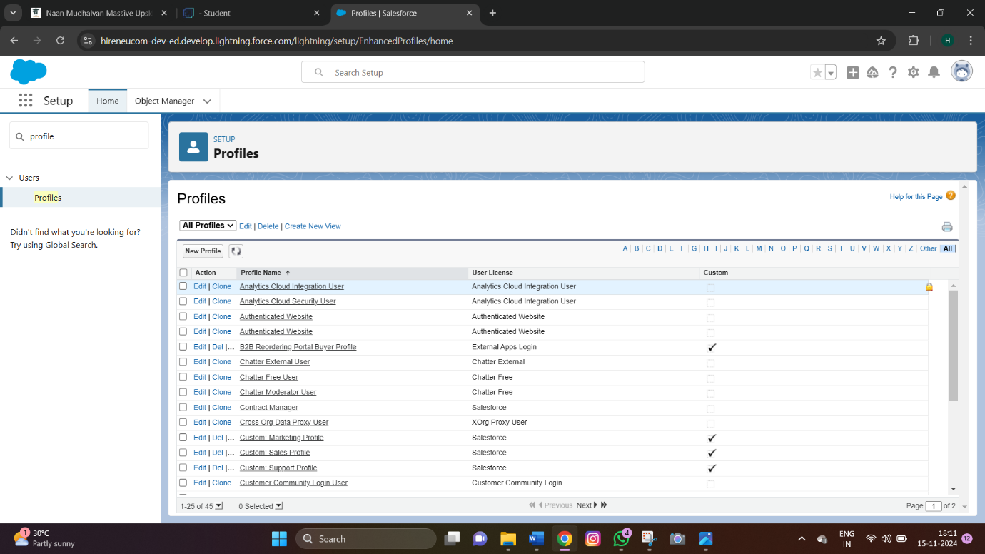



STEP 9:ROLES

**Role**

A role in Salesforce defines a user's visibility access at the record level. Roles may be used to specify the types of access that people in your Salesforce organization can have to data. Simply put, it describes what a user could see within the Salesforce organization.

**Activity 1: Creating HR Role**

1. Go to quick find --> Search for Roles --> click on set up roles.
2. Click on Expand All and click on add role under whom this role works.
3. Give Label as “HR” and Role name gets auto populated. Check to whom this role (HR) reports. Then click on Save.

**FIGURE 11:**

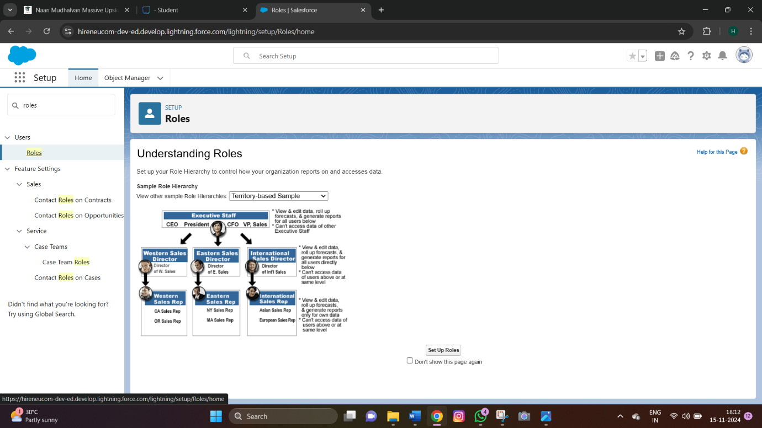

STEP 10:USERS

**Users**

A user is anyone who logs in to Salesforce. Users are employees at your company, such as sales reps, managers, and IT specialists, who need access to the company's records. Every user in Salesforce has a user account. The user account identifies the user, and the user



account settings determine what features and records the user can access.  
Username

1. Email Address
2. User's First Name (optional)
3. User's Last Name
4. Alias
5. Nickname

**FIGURE 12:**

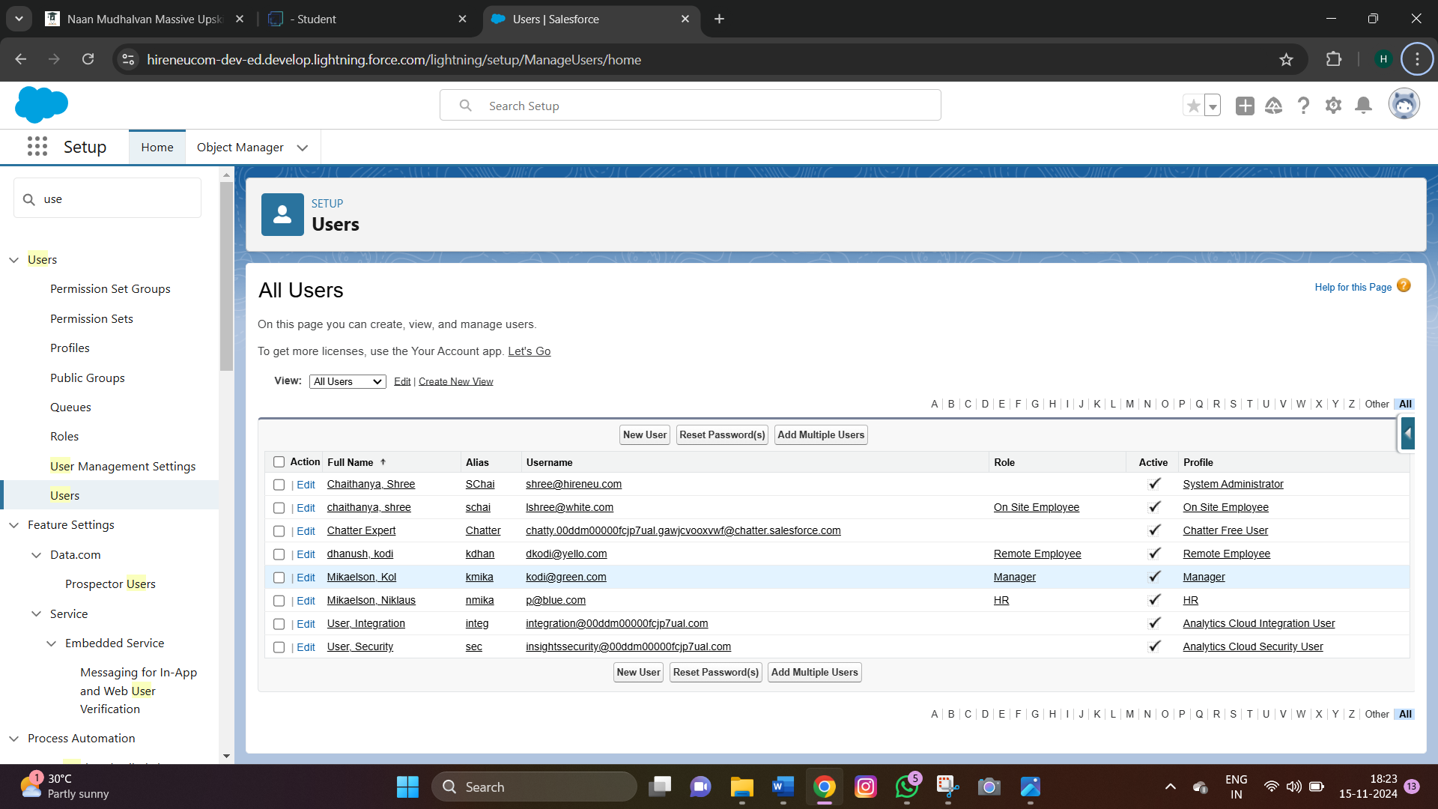

STEP 11:PAGE LAYOUTS

**Page layouts**

Page Layout in Salesforce allows us to customize the design and organize detail and edit pages of records in Salesforce. Page layouts can be used to control the appearance of fields, related lists, and custom links on standard and custom objects' detail and edit pages.

**Activity 1 : creating a page layout for Employee object**

To Create a Page layout:

1. Go to Setup --> Click on Object Manager --> Search for the object (Employee) --> From drop down click on Edit.
2. Click on Page layout --> Click on New.



1. Give Page layout Name as “On Site Employee Layout” and click on Save.
2. Drag and drop the Section from the highlight panel below the Information and name it as “Personal Information” and click Ok.
3. Drag Date of Birth, Address and Age fields from Employee Information to Personal Information section.
4. Similarly perform the above step to create “Allowances” and add allowances fields in it as shown below.C.
5. Click Save.

**FIGURE 13:**

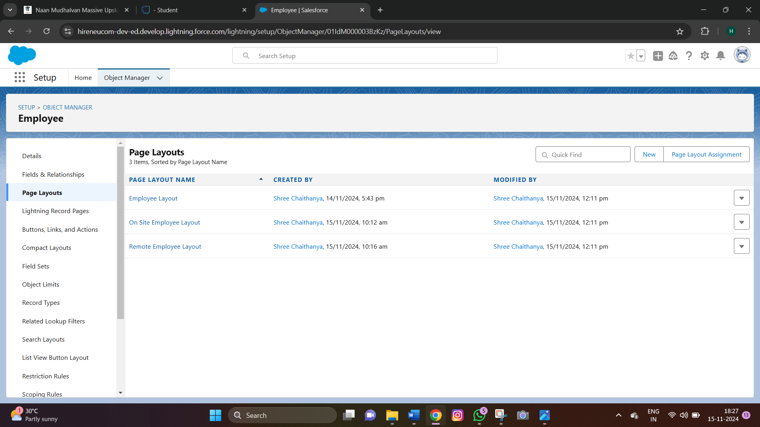

STEP:12 CHATTER GROUP

**Chatter group**

Salesforce Chatter Groups are collaborative spaces within the Salesforce platform that enable teams to communicate, share information, and collaborate on projects. They provide a centralized hub for discussions, file sharing, and updates, allowing users to stay connected, streamline workflows, and enhance productivity.

**Activity 1 : Creating a chatter group for your organization.**

1. Click the App Launcher.



1. Enter Groups in the Search apps and items... box and select Groups.
2. Click New.
3. Fill in the new group information with these details:
4. Click Save & Next. Skip the Upload Picture section and click Next.
5. On the Manage Members screen, click Add next to users you created in the previous activity.
6. Click Done.

**FIGURE 14:**

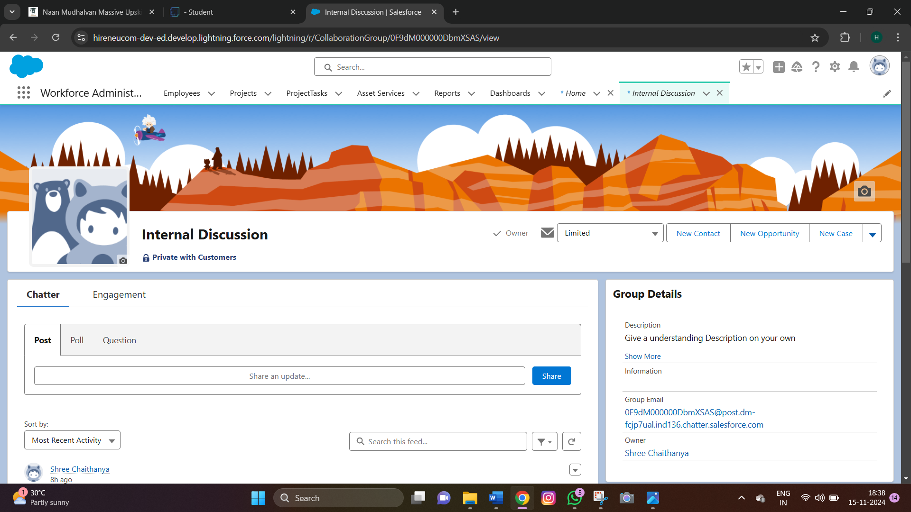



**FIGURE 15:**

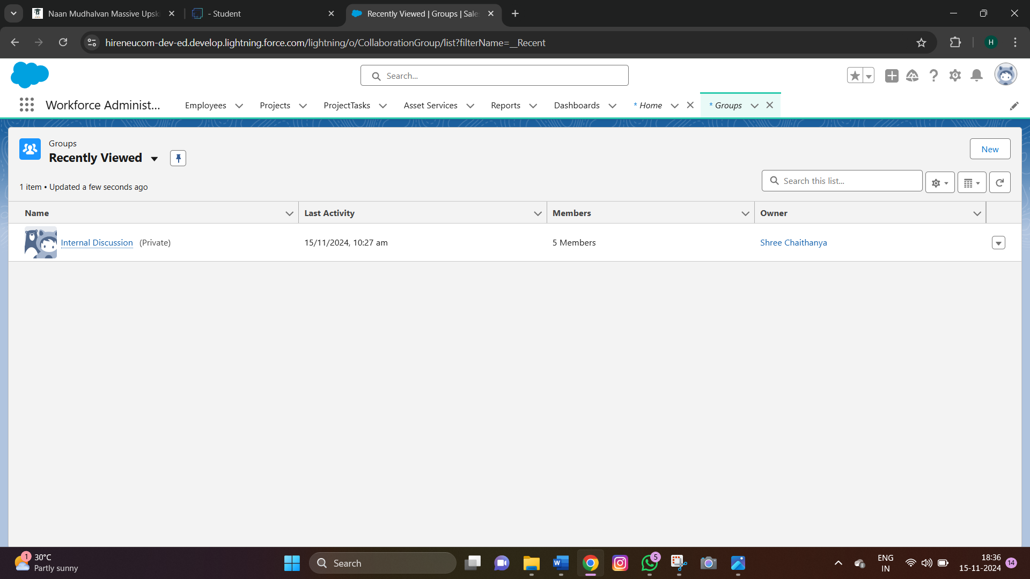

STEP 12: RECORD TYPES

**Record types**

Record Types are a way of grouping many records of one type for that object. These can be applied to any standard or custom object, and allow you to have a different page layout, fields, required fields, and picklist values. Record types allow administrators to create a different page layout with custom picklist fields and values for the same business process and various business processes.

**Activity 1: Creating On Site Employee Record Type**

To create a Record Type:

1.     Go to Setup --> click on Object Manager --> Search for the object (Employee) --> from drop down click Edit.

2.     From the left panel click Record Types --> New.

3.     Give Record Type Label as “On Site Employee” and make it active.

4.     Uncheck for “Make Available”.

5.     Scroll  down and check for the Manager & System Administrator profile and click on Next.



6. Select “Apply a different layout for each profile”, and change page layout to On Site Employee Layout for manager profile and System Administrator.

7.     click Save.

**FIGURE 16:**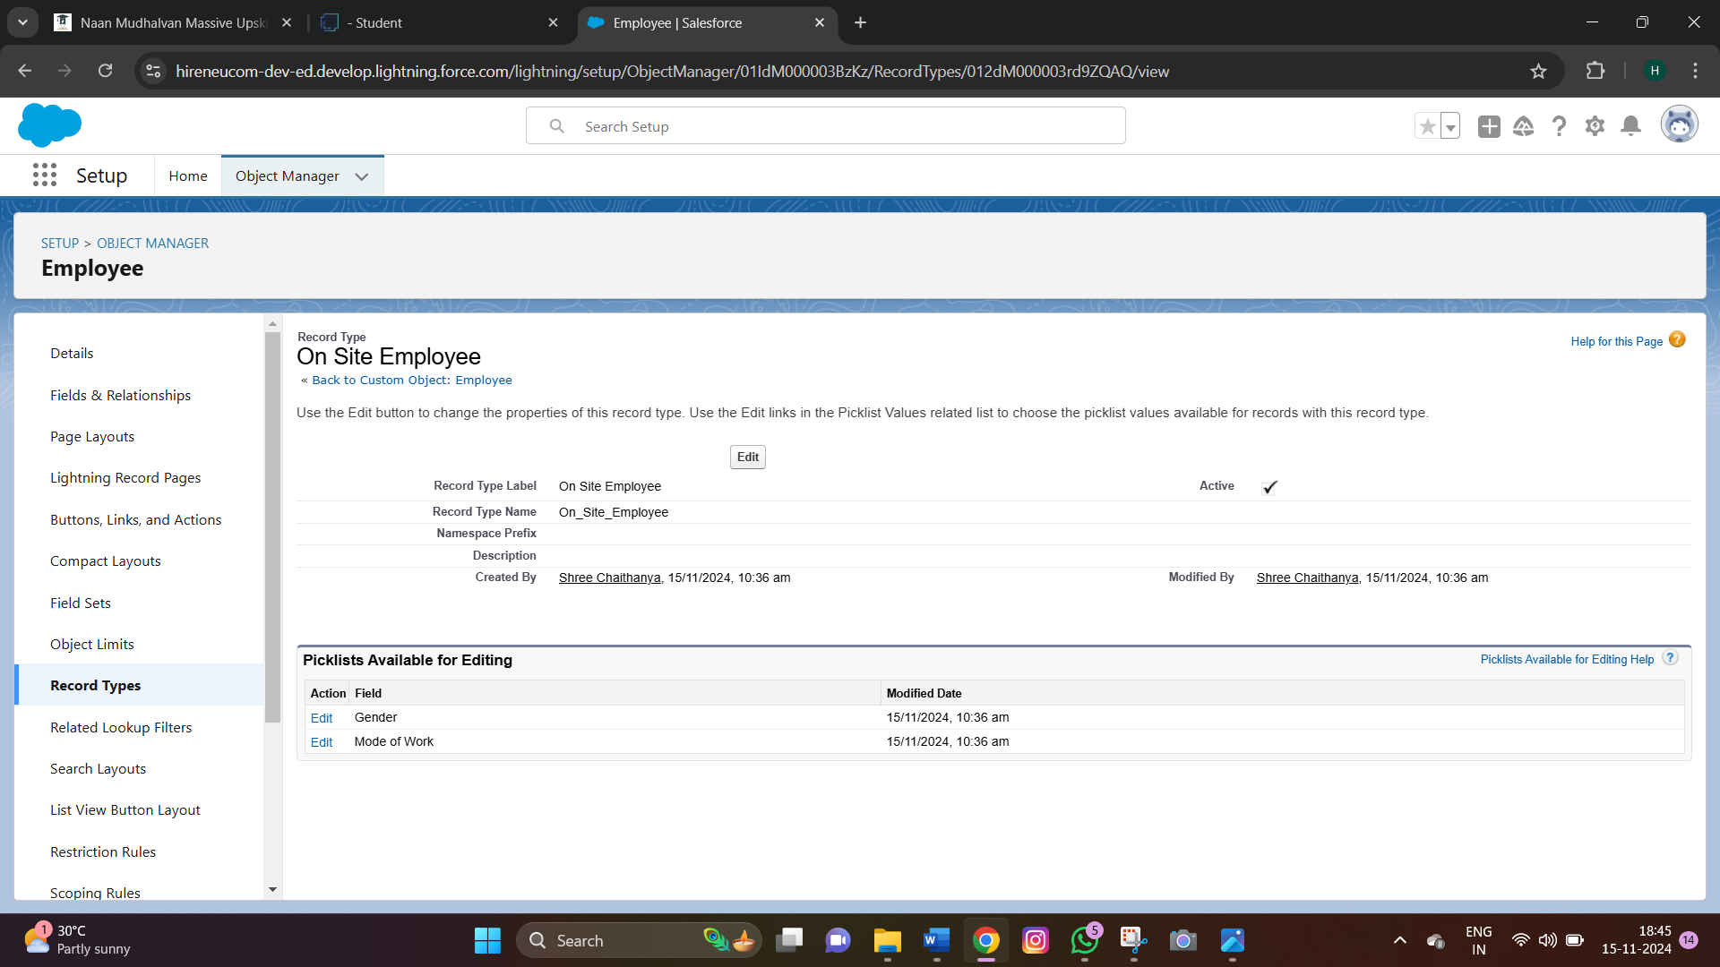

**Activity 2: Creating "Remote Employee" Record Type**

Create another Record Type with name “Remote Employee” following the step from activity

**FIGURE 17 :** 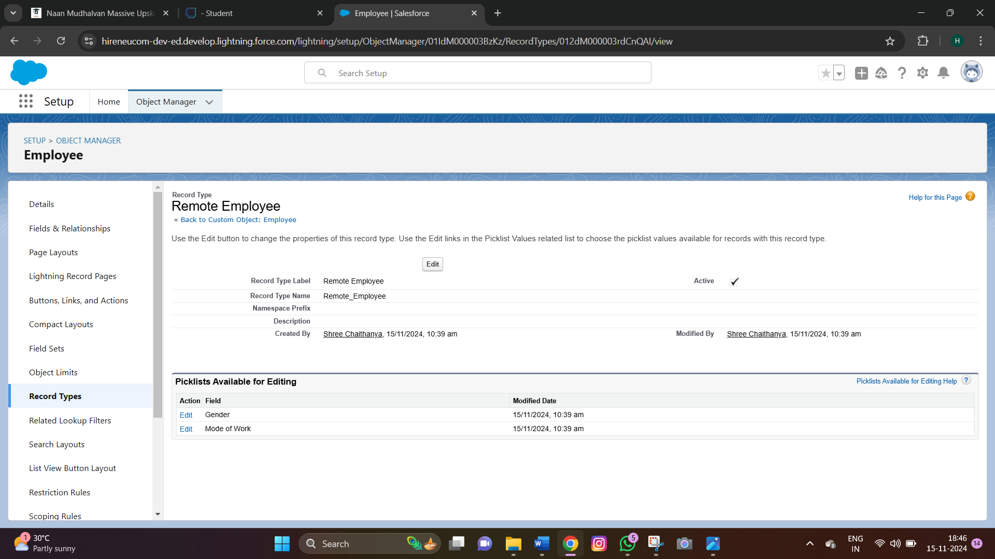



**FIGURE 18 :**

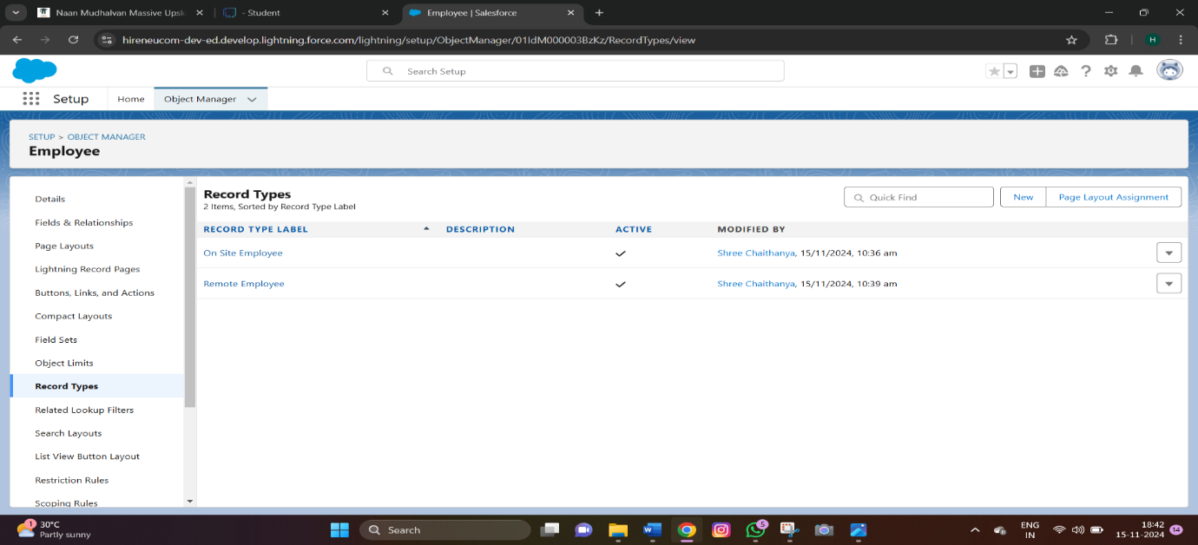

STEP 13:PERMISSION SETS

**Permission sets**

A permission set is a collection of settings and permissions that give users access to various tools and functions. Permission sets extend users' functional access without changing their profiles. Users can have only one profile but, depending on the Salesforce edition, they can have multiple permission sets.

**FIGURE 19:**

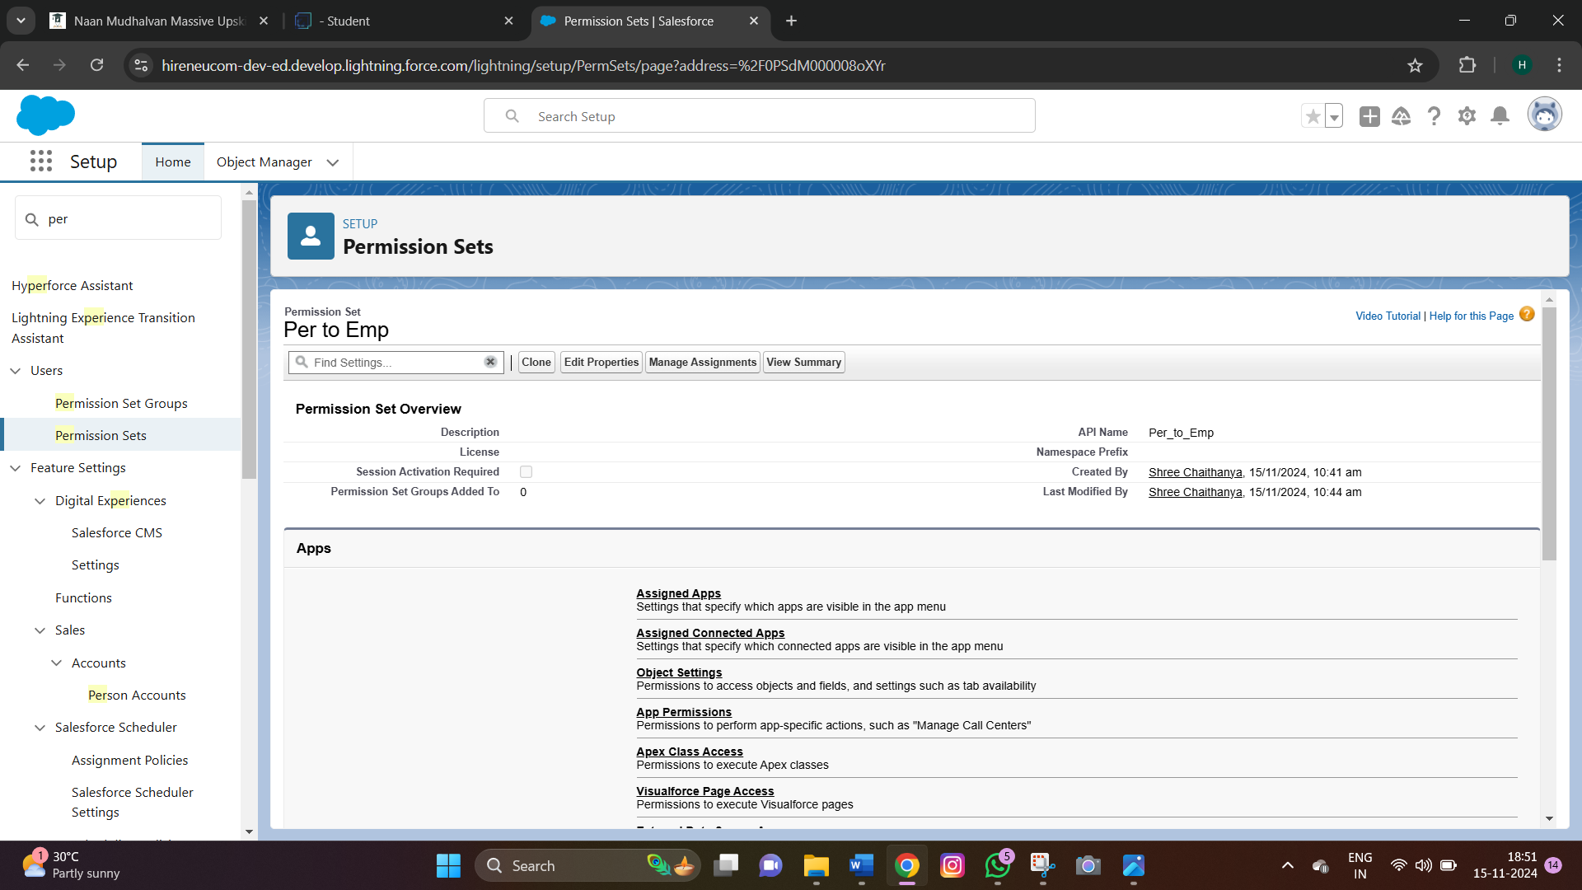



**FIGURE 20:**

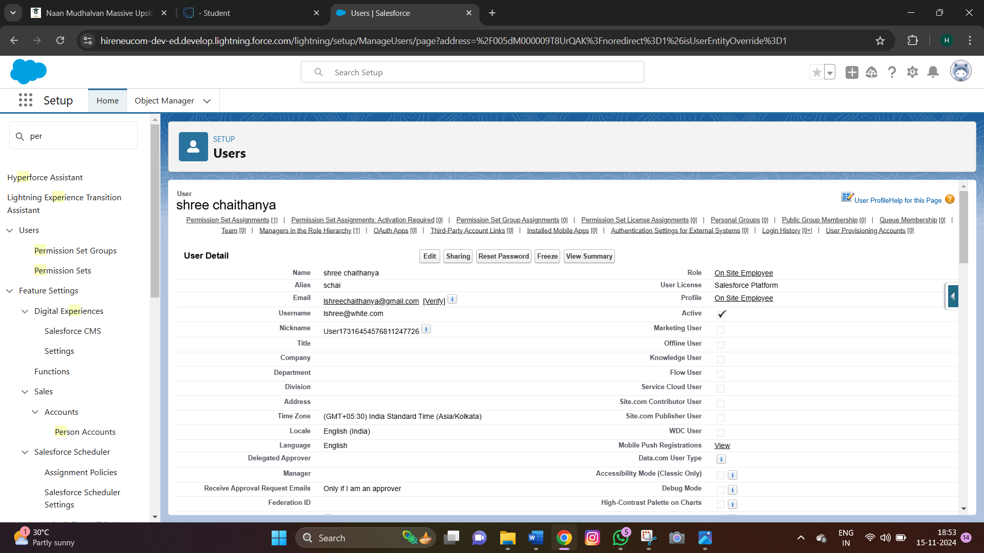

STEP 14:REPORTS

**Reports**

Reports give you access to your Salesforce data. You can examine your Salesforce data in almost infinite combinations, display it in easy-to-understand formats, and share the resulting insights with others. Before building, reading, and sharing reports, review these reporting basics.

**Activity 1: Create Report**

To Create a Report:

1. Go to the app --> click on the reports tab
2. Click New Report.
3. Customize your report
4. Add fields from left pane as shown below
5. Save or run it.

**Activity 2: Create 2 more Report**

1.     Create a report with report type: “Employees with ProjectTasks and Projects”.

2.     Create a report with report type: “Employees with Assets”.



**FIGURE 21 :**

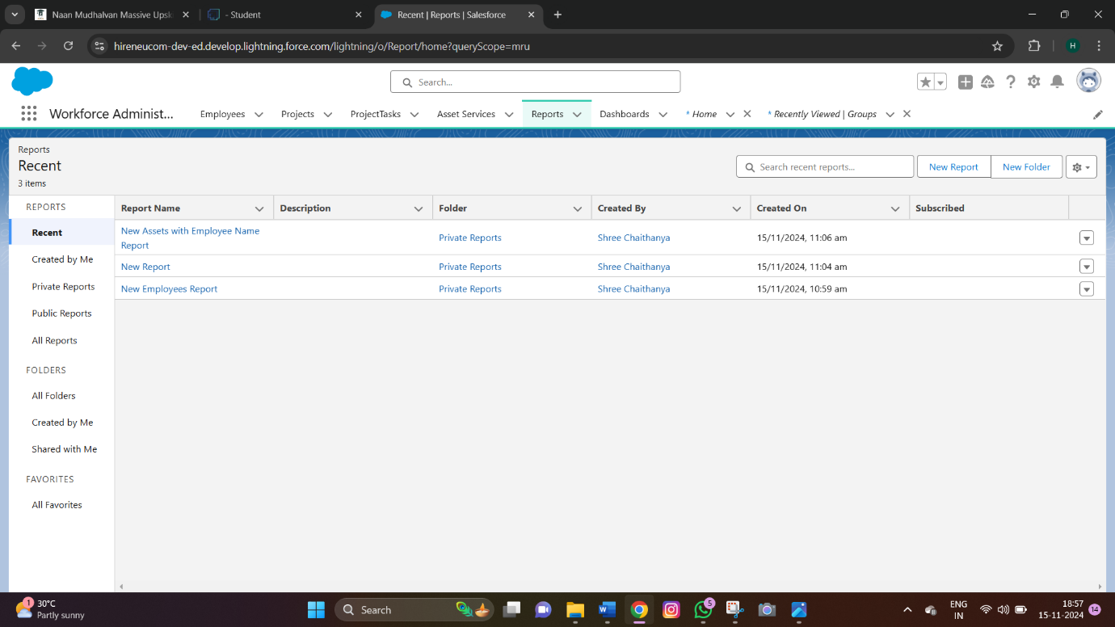

STEP 15:DASHBOARDS

**Dashboards**

Dashboards help you visually understand changing business conditions so you can make decisions based on the real-time data you’ve gathered with reports. Use dashboards to help users identify trends, sort out quantities, and measure the impact of their activities. Before building, reading, and sharing dashboards, review these dashboard basics.

**Activity 1: Create Dashboard**

To Create a Dashboard

1. Go to the app --> click on the Dashboards tabs.
2. Give a Name and click on Create.
3. Select add component.
4. Select a Report and click on select.
5. Click Add then click on Save and then click on Done.



**FIGURE 22 :**

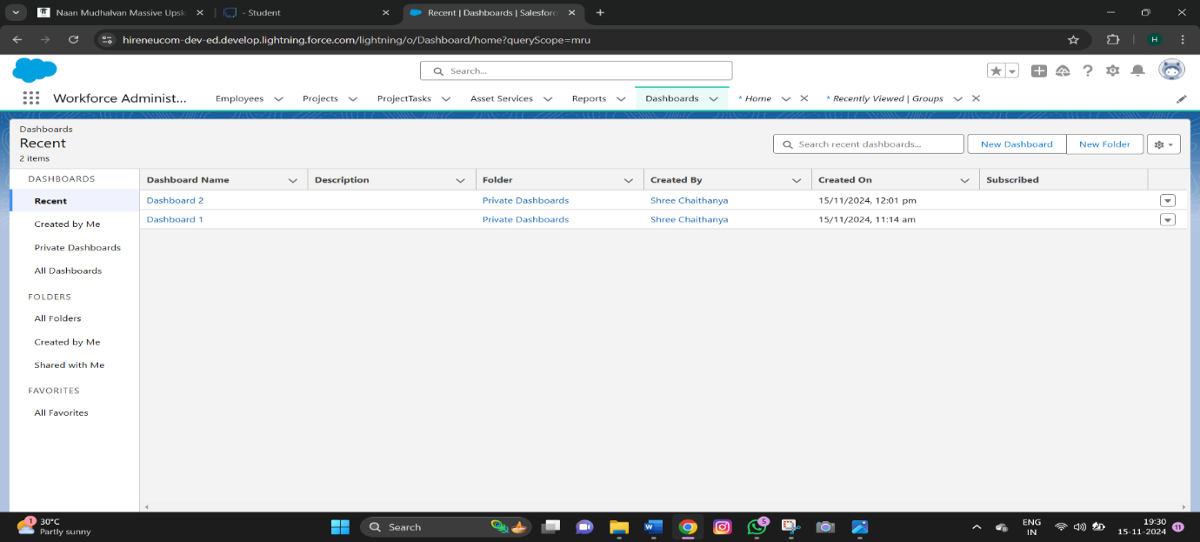

STEP 16:APPROVAL PROCESS

**FIGURE 23 :**

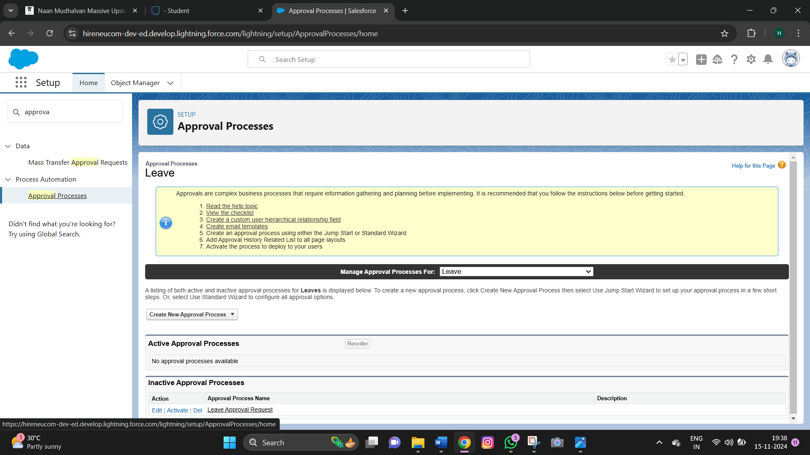



**FIGURE 24 :**

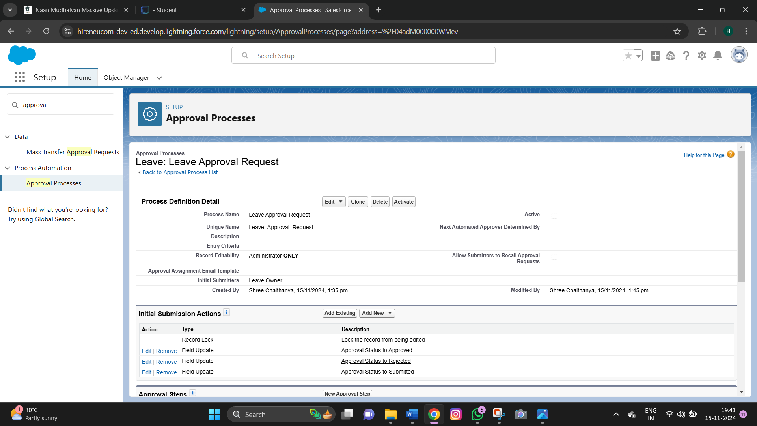

**FIGURE 25 :**

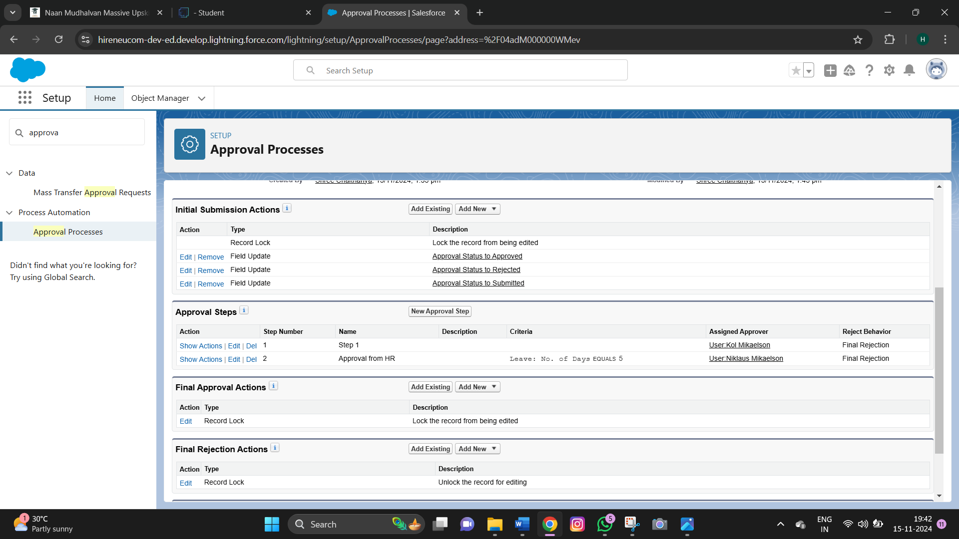



STEP 17:APEX TRIGGER

**Code Snippet:**  
trigger EmpInsert on Employee__c (before insert) {

for(Employee__c pass : Trigger.New){

List<Employee__c> mynew = [SELECT Id, Name FROM Employee__c WHERE Employee_Name__c =: pass.Employee_Name__c];

if(mynew.size() > 0){

         pass.Name.addError('Employee with same name is existing');

  }

}  
}

**FIGURE 26:**

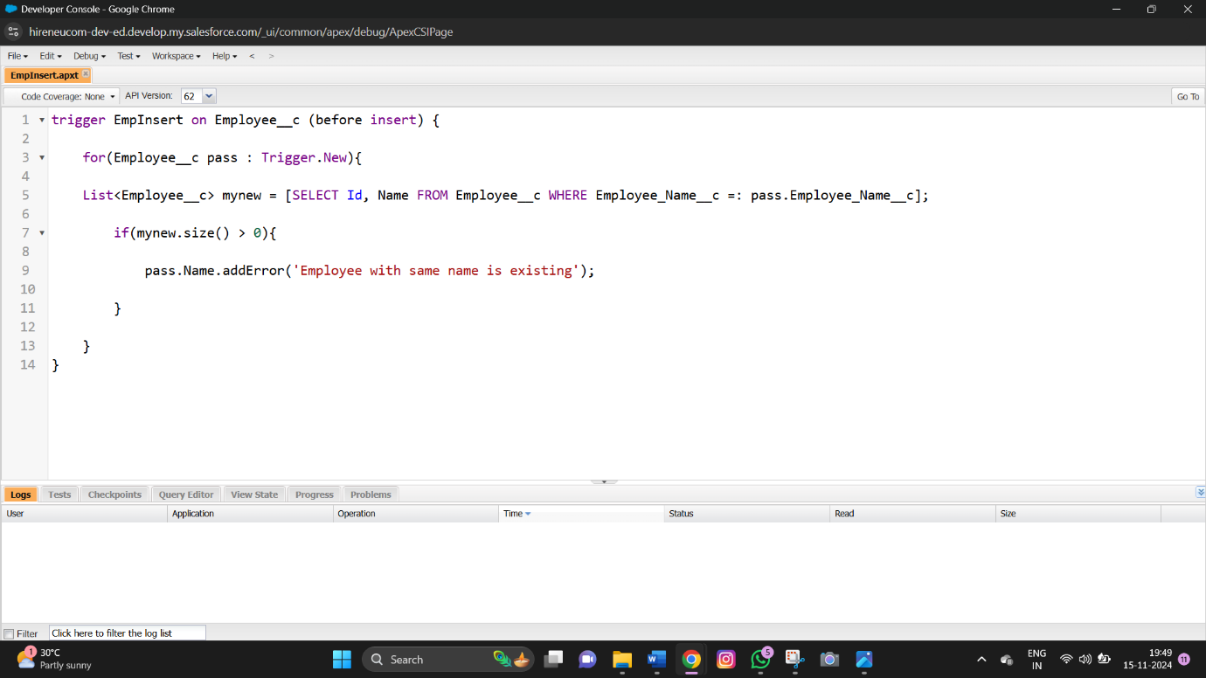



**8. CONCLUSION:**

* The *Workforce Administration Solution* project successfully developed a comprehensive platform for managing employee, project, and asset data within a centralized Salesforce application. This solution not only met the objectives of enhanced data visibility and management but also demonstrated effective automation, reporting, and user interface customization, which resulted in improved operational efficiency.

**Key achievements included:**

* Implementing robust data models for seamless integration and scalability.
* Customizing user interfaces to enhance usability and accessibility.
* Automating manual processes, leading to improved operational efficiency.
* Developing real-time reports and dashboards for actionable insights into employee performance and asset utilization.
* The project also overcame challenges such as bulk data import complexities, performance issues with large datasets, and customization limitations within Salesforce through innovative solutions like data validation, batch processing, and leveraging advanced Salesforce components.
* Overall, the *Workforce Administration Solution* not only fulfilled its objectives but also demonstrated the value of leveraging modern platforms like Salesforce for comprehensive workforce and asset management. It stands as a scalable and efficient framework, with potential for further enhancements such as integration with external HR systems and advanced analytics, to meet evolving organizational needs.

------------------------------------------------------------------------------------